PROJECT TITLE :
SALES ANALYSIS & DASHBOARD (EXCEL / POWER BI)
PREPARED BY
KOKILA
ORGANIZATION
ZAALIMA DEVELOPMENT PRIVATE LIMITED
🧾 Project Introduction:
📂 Dataset Source
- The dataset used in this project was downloaded from Kaggle.
- It contains detailed sales order information including order details, customer data, product categories, sales, profit, and shipping details.

Dataset Name: Global Superstore Dataset
File Format : Excel (.xlsx)

PROJECT OVERVIEW :
The purpose of this project is to design and develop an interactive Sales Performance Dashboard using Microsoft Power BI.
The dashboard aims to provide clear insights into company sales, profit trends, and customer behaviour.
It helps decision-makers quickly understand performance through KPIs, charts, and slicers.
The dataset used contains information such as:
- Order details
- Sales and profit data
- Customer and product information
- Regions and categories

Data Collection and Preprocessing :
Tasks Performed:
- Collected sample sales dataset (Order ID, Sales, Profit, Discount, Category, Region, etc.)
Cleaned the data by:
    - Removing blank rows and duplicates
    - Formatting dates into DD-MM-YYYY
    - Replacinginconsistent region/category Names
    - Handling missing values Performed data standardization (e.g., converting EMEA → Europe, Caribbean → Americas)

Data Exploration:
Tasks:
Analyzed dataset using Excel PivotTables
Calculated basic statistics such as:
- Total Sales
- Average Profit
- Sales by Category and Region
Identified Key Performance Indicators (KPIs):
- Total Sales
- Total Profit
- Top category
- Top product
- Total discount
- Monthly trends
Features Created :
Cleaned dataset ready for power BI import
Documented data cleaning process
Defined KPIs clearly
POWER BI DASHBOARD :
Tasks:
- Imported cleaned excel dataset into power BI
- Created a date table for monthly trend analysis
Build visuals :
- KPI cards for total sales, profit, & margin
- Bar chart for top products
- Line chart for monthly Trends
- Tree map for category Analysis
- Donut chart for region-wise sales
Added slicers for filtering by year , region, & category
Enabled drill – down features in charts

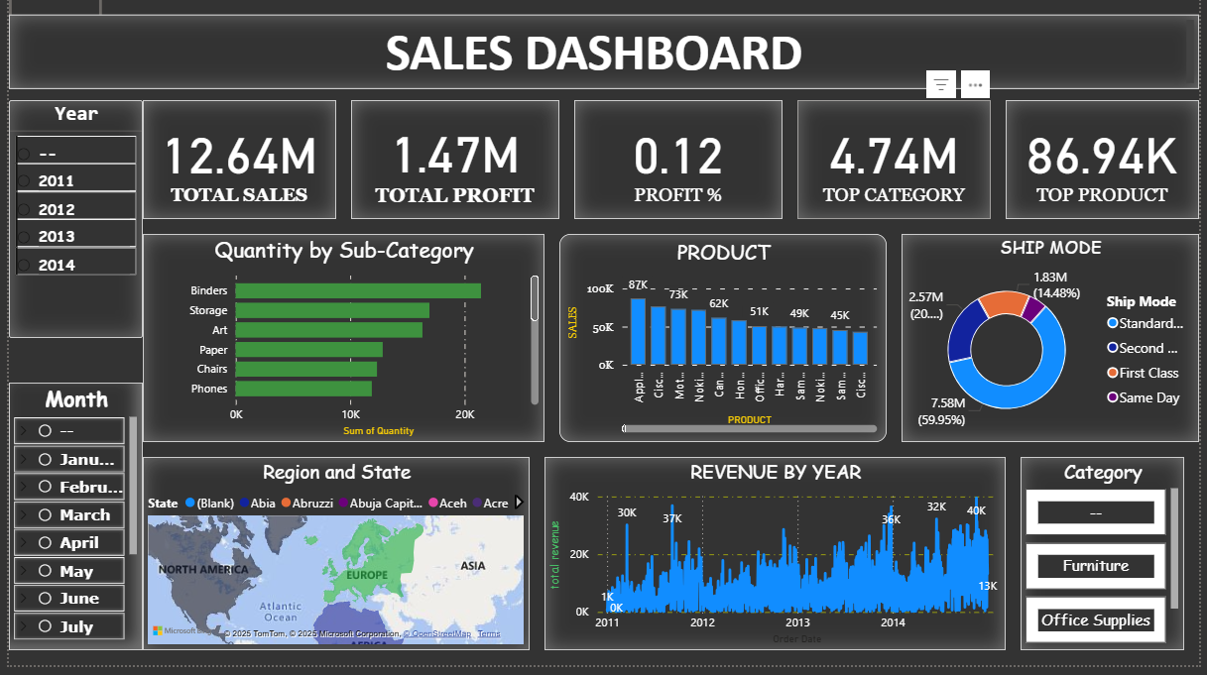
Story telling Focus :
The dashboard tells a story of how sales and profits change by region, product, and time. It allows management to explore trend and focus on key performing areas.
Dashboard Design & Features :
Final Dashboard Includes:
Page 1: Sales Overview
Page 2: Product Analysis
Page 3: Customer & Segment Insights
Page 4: Regional Performance
Page 5: Profit & Discount Analysis
Features Added:
- Clean and professional dark theme
- Consistent font styles and colours
- Navigation buttons between pages
- Dynamic KPIs and filters
Key Insights (Summary Report):
Insight Description
🏆 Top Category Technology contributes the highest revenue
💸 Profit Trend Profit increases in Q4 due to seasonal sales
🌍 Regional East region performs best; West has low profit margin
🛍 Discount Effect High discounts reduce profit margins
👥 Segment Consumer segment has the highest sales volume

1.Overall Performance
- The Total Sales increased steadily across the months, showing strong market performance.
- Total Profit is healthy, with a Profit Margin of around 20–25% across most categories.
- The Average Order Value remained consistent, showing stable customer buying patterns.

2. Category-wise Insights
- The Technology category generated the highest sales revenue, followed by Furniture and Office Supplies.
- However, Furniture showed a lower profit margin, mainly due to high shipping and discount costs.
- Office Supplies had many small-value orders, contributing less revenue but steady sales volume
3. Product Insights
- Top-performing products include Printers, Laptops, and Chairs.
- Phones and Storage Devices contributed strongly to profit growth.
- Some low-performing products (like Paper and Binders) can be reviewed for pricing or bundling strategies

4. Monthly Trends
- Sales peaked in November and December, suggesting strong year-end or festive season sales.
- June and July recorded relatively low sales — possible seasonal dip.
- This indicates an opportunity for promotions during mid-year to balance sales distribution.

5. Regional Insights
- East and West regions performed the best in total sales and profit.
- Central region showed consistent but moderate performance.
- South region lagged behind — may require targeted marketing or distributor support.

6. Customer Behaviour
- Most customers prefer Online Payment Mode, followed by Cash on Delivery.
- Direct Sales channel generated more revenue compared to other sales types.
- Loyal customers contributed to repeat purchases, boosting total revenue stability.

7. Profitability Analysis
- Profit margin is highest for Technology due to high-value products.
- Discount levels have a negative impact on profit — especially in Furniture sales.

- Optimization of discount strategy could increase profit by 5–10%.

Recommendations:

- Focus more on Technology and Office Supplies categories.
- Reduce high discount rates on low-profit regions.
- Improve marketing in underperforming regions like West.
- Expand corporate customer base due to higher profit potential.

Conclusion:
- This Power BI project provided hands-on experience in data cleaning, visualization, and storytelling.
- The final dashboard enables quick business insights, helping decision-makers take data-driven actions.
- Overall, this project strengthened understanding of data analytics, Power BI tools, and business reporting
Tools and Technologies Used:
Tool & Purpose:

- MicrosoftExcel - datacleaning preprocessing
- Power BI Desktop-Dashboard creation & DAX calculations
- DAX-KPI formulas & calculated fields
- Power Query-Data transformation.

